Soriano, Shelita

WEB 231 - 9.2

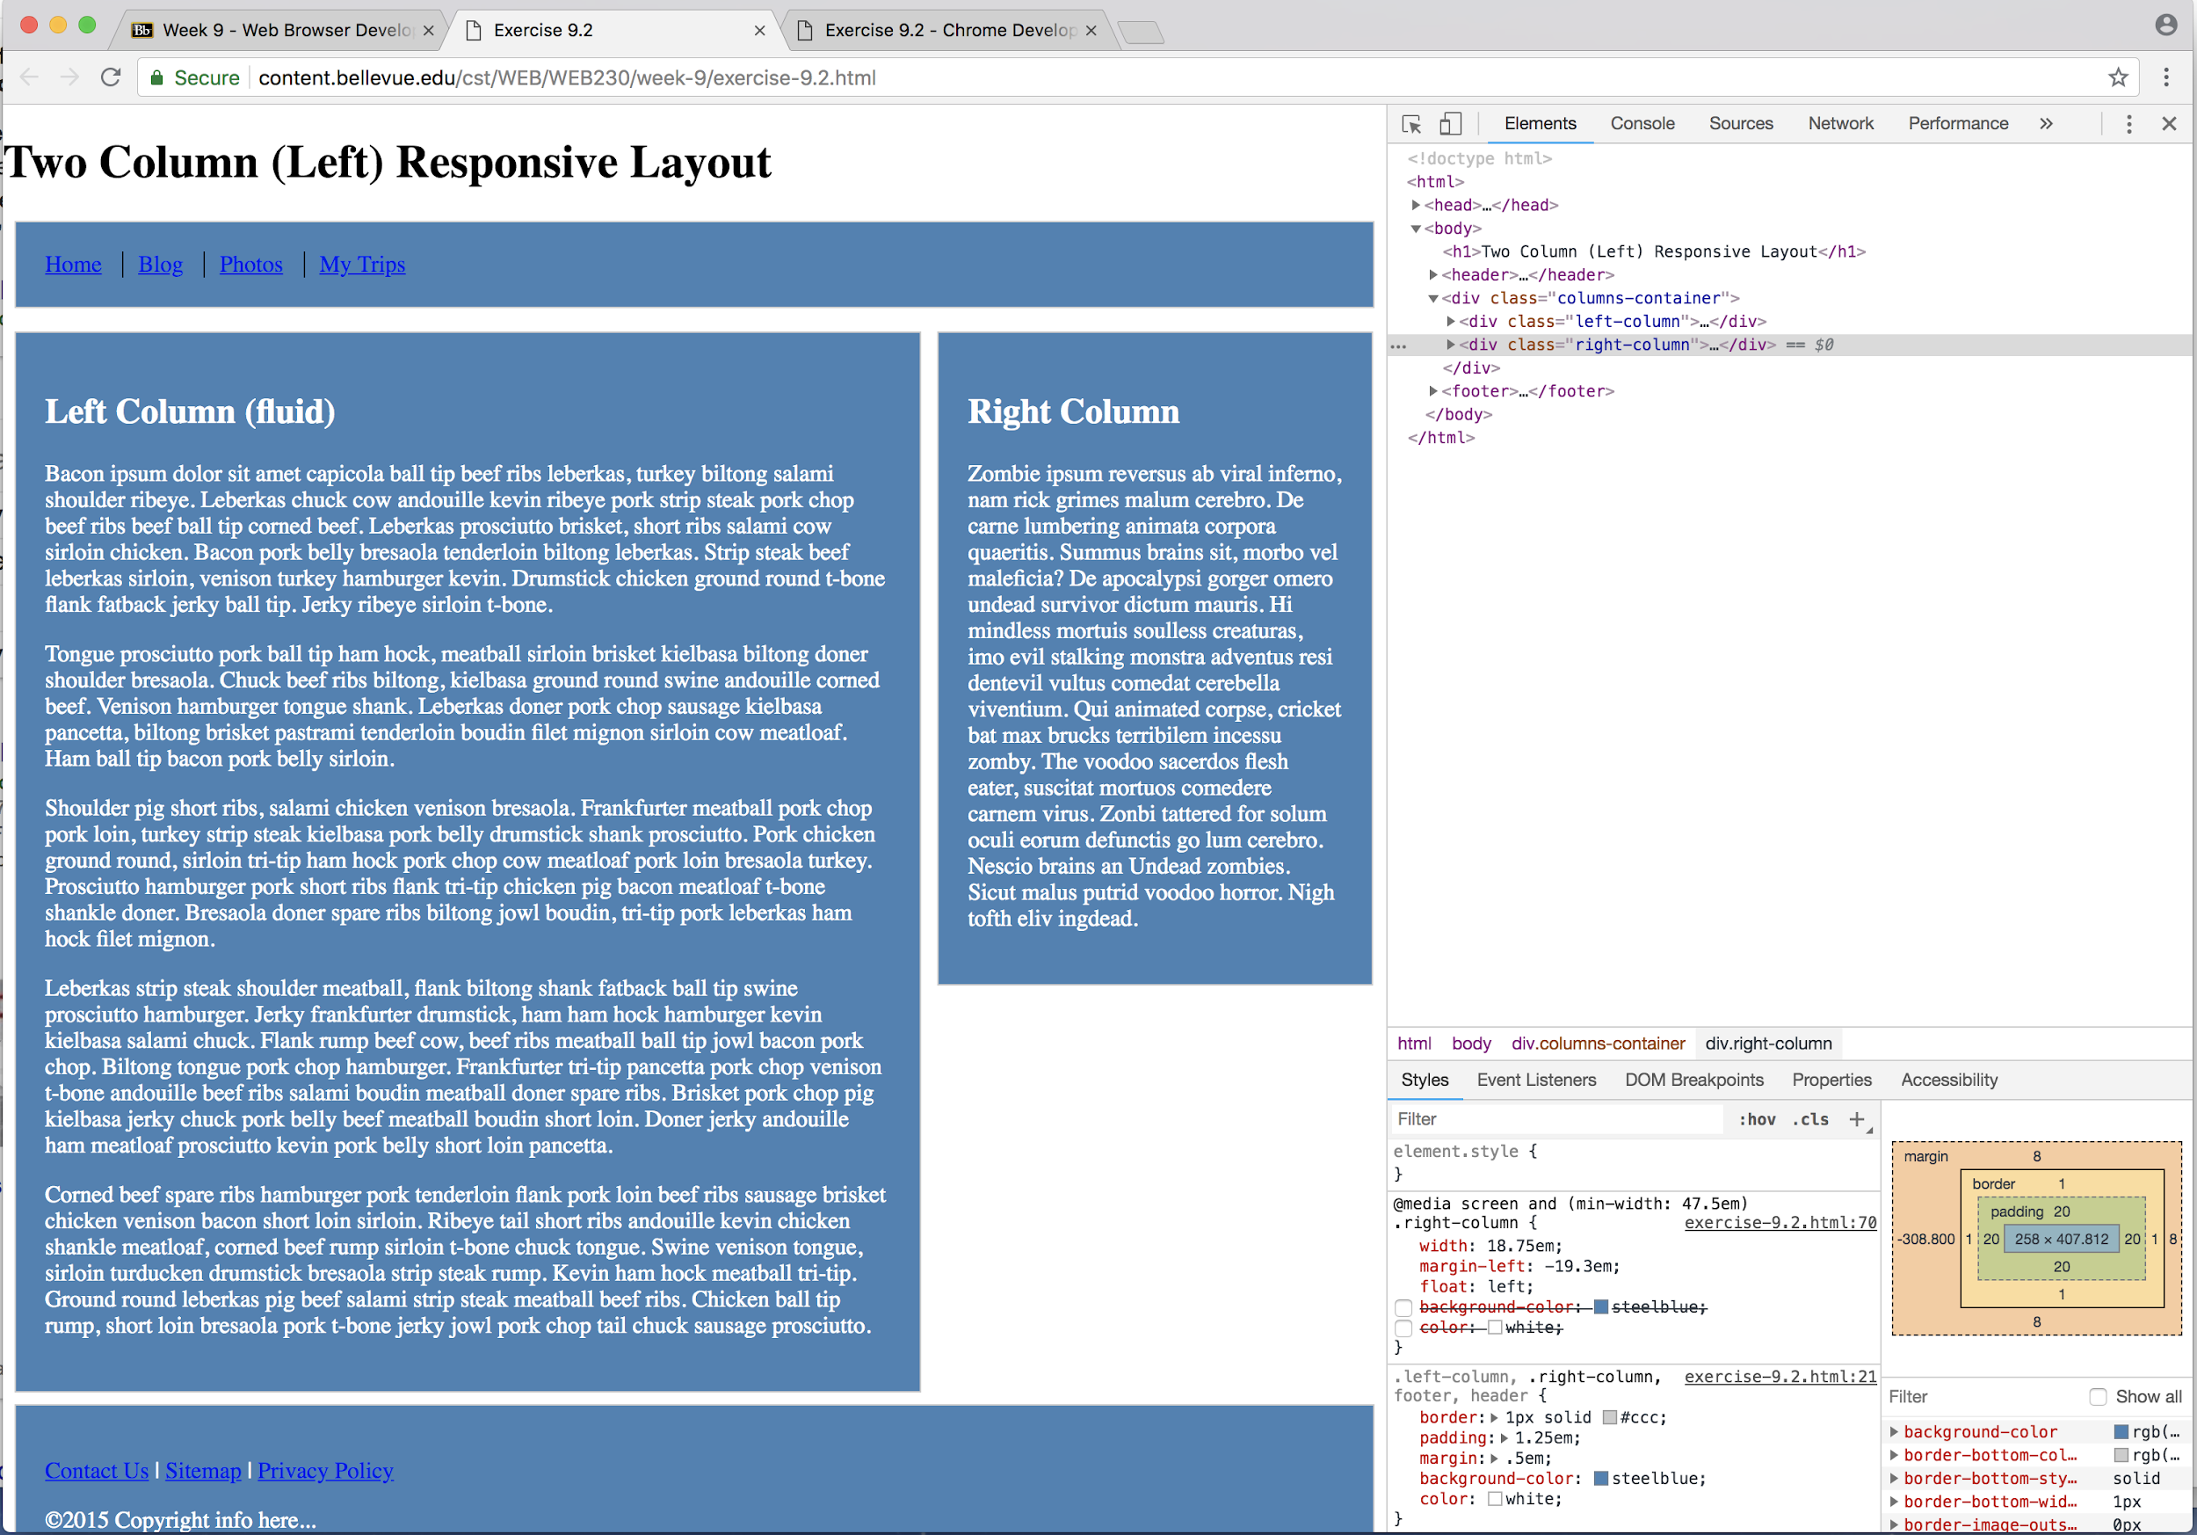

Instructions to a 6 year old of how I modified the page.

If you want to play around and change different backgrounds or text color on a web page, follow these instructions.

1. Open up a web page using Chrome browser
2. On the top right of the webpage, click on the 3 dots, and choose “More Tools”, then “Developer Tools”.
3. Then click on “Elements” on the tabs.
4. Click on drop down arrow where it says “div class = “Column-container”.
5. Then click or highlight “right column” div.
6. On the section where it says “Styles”, look for .right-column and .left-column, and in between the { } curly braces where you see border:, padding: margin: Under those words, type... background-color: steeleblue; Then hit Enter.
7. Then type... color: white;. Then hit Enter.